2.76: The time needed for the egg to fall is

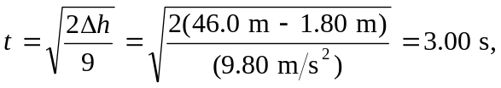

and so the professor should be a distance v_{y}t = (1.20 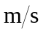)(3.00 s) = 3.60 m.

